SEPTEMBER 2022
BUCKEYE BREEZE

Sisters,
Just hard to believe two months have passed already.
Visited Reynoldsburg #3261 for the Auxiliary Past President Charter Draping, very impressive.
I was the guest speaker and was treated like royalty and very impressed with everything they presented. Looking forward to visiting as many Auxiliary’s as possible and just traveling throughout Ohio and having some fun.
Looking forward to Leadership, which will be in Zanesville and I know their Aerie and Auxiliary will do a great job.
Hey Sisters, don’t forget your charities, please do all you can to support them. Don’t know for sure but hope to have our charity tables at Leadership, so bring a few extra dollars with you.
Looking forward to seeing all the Brothers and Sisters and having a good weekend.
So until then, safe travels and remember attend your local and district meetings because you are the Members that keep the EAGLES thriving.
Carol Giles, State Madam President Snow Princess

Carol Giles Sandy Graham Debbie Sharp State President Buckeye Breeze Editor State Secretary 21 Highland Heights 736 Wauseon Senior Village Dr. 404 Kennison Ave. Wheeling, WV 26003 Wauseon, Oh. 43567 New Carlisle, Oh. 45344 304 639 4686 419 250 9693 937 679 8002 cgiles995@hotmail.com breezysandy@yahoo.com deldridgesharp@aol.com

October Birthdays
5th Mary Miller, PSP…………………………………….……….419 350 1541 18th Stacey Mack, SO………………………………………………440 856 5026 22nd Chloris (Corky) Vance, PSP ………………………..……740 826 7149 31st Luria Thompson, PSP………………………………………937 528 9317

October Anniversary’s
1st Connie Arnold PSP, PECRP, OSSA & Paul …………..740 984 4151 3rd Mary Hornsby PSP, PECRP & Mike………………..…...419 668 0213 12th Judy Joy PSO & Rich …………………………………………330 424 9473 23rd Debbie Sharp SO & Chuck …………………………………937 679 8002

We are very sad to pass on the news of the passing of PSO Ron Luke, husband of ECRP, PSP Harriet Luke and father of 1st State Vice President Stacey Mack. Please keep the family in your thoughts and prayers.
Cards can be sent to the family/Harriet at: 9788 N. Marks Road, Columbia Station, Ohio 44028
Stacey Mack, 140 Sprucewood Drive, Seville, Ohio 44273

We received information from Barb Stull’s oldest daughter that Barb has been very ill and has been transported to Valley View in Fremont for rehab. If you would like to send Barb a get well card it can be sent to her home address: 1080 Level Dr. , Fremont, Ohio 43420. Her daughters stop and get her mail daily and will be happy to give to Barb. She will be there 30 – 60 days, depending how she does getting her strength back. Hopefully all the cards will inspire her and lift her spirits.

Mary Miller, PSP, was in the hospital for a few days with some health issues. She is home now recuperating. Cards may be sent to: 2661 Thunderbird Trail, Lambertville, MI 48144

Note from State Inside Guard Anita Kennedy: I just wanted to thank the Nominating Committee for choosing me for the Inside Guard and wanted to thank everyone for prayers and thoughts during my surgery.
A friendly get-well or thinking of you lifts our spirits !!
I want to thank everyone that came out and spent the day at the Rec Park for All Zones Day. I hope that you had a good time and will come back and visit the Rec Park again.
I want to give a big thank you to all the brothers and sisters that volunteered their time in any way that day. It is greatly appreciated. Also, thank you for the donations for the raffles, food, beer and especially the monetary donations.
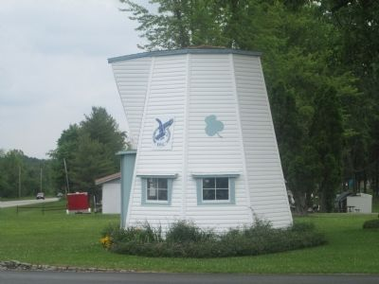
I am sending to the State Office a check for $6,830.00. So, THANK YOU again for making All Zones Day a success.
Fraternally, Dave Favorite, Rec Park Chairman

Gas Card Raffle
Muscular Dystrophy Charity
$10 dollars a ticket
1st place wins $100 Gas Card
2nd place wins $50 Gas Card
Contact Mary Andrzejewski
Zooko38@gmail.com
567-277-8276
Winners will be announced at Spring Zone in April

A Winter Night
The sky is dark and the ground is white. The world is peaceful on this wintery night. No one around, not a sound to be heard. Not a laugh, not a car, not even a bird. For a moment, it’s just the snow and me. I smile inside. I feel so free

Sisters:
I would like to take this opportunity to thank all the Ohio sisters who assisted the PGMP’s in selling candy at the International Convention. We had 15 PGMP’s in attendance, some of whose mobility is limited, so it was necessary to ask for help and as usual you were there for us. All money collected from the candy is used to donate to charities.
Many thanks to the Sisters who made sure I had an Ohio Flag and treats were behind my Name Card each day.
Love to all,
Judy Sanders, PSP, PGMP

Pineapple Cheeseball
2 - 8 oz cream cheese – softened 1 - 8 oz crushed pineapple – drained well ¼ cup finely chopped green peppers ¼ cup green onions finely chopped 1 tsp salt 1/3 cup finely chopped pecans to mix with cheeseball
1 cup finely chopped pecans to roll cheeseball in.
Serve with crackers

Quarter Auction ~ 42 Draw ~ Chinese Raffle
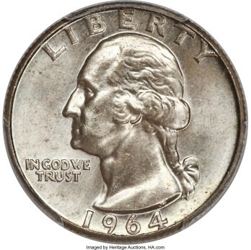
For 1st Vice Stacey Mack
Saturday, October 15th, 2022
Doors open at 11:30 am
Bellefontaine Eagles
213 West Chillicothe Street
Bellefontaine, Ohio 43311
$5.00 – First paddle, additional paddles $1.00 each We will also offer “All In” Paddles (Price to be determined at a later date) There will be a Chinese Raffle, 50/50 and other raffles thru out auction. Food will be available. So come out and support Stacey as she begins her journey as your Next Ohio State Auxiliary President
Tickets for 42 Draw are $5.00

LEADERSHIP TEA
ZANESVILLE #302 – SEPTEMBER 17TH, 2022
The Board of Trustees is again asking for your help with donations for the Tea. We would be grateful if our PSPs would help with finger foods and State Officers and others to bring cookies, candy, nuts, etc. Thanking everyone in advance for your help with the Tea. Your State Trustees

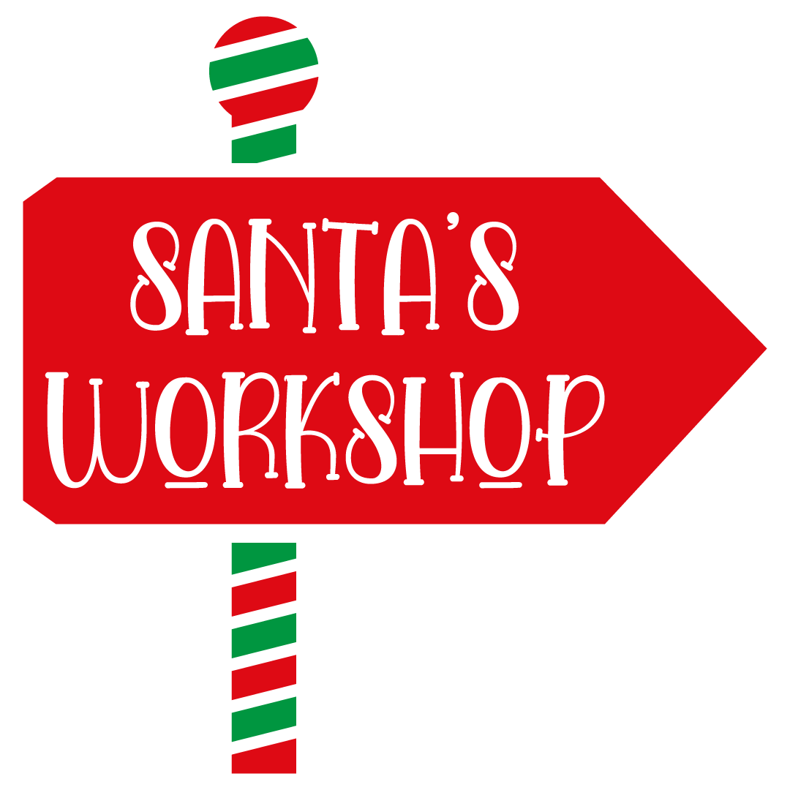
Fall Zone Assignments
Northeast Zone ~ Salem #316 ~ October 1 & 2
Chairman – Agnes Smith Secretary - Pam Kohlrieser Speaker - Anita Kennedy Zone Coordinator – Kelly Beech
Northwest Zone ~ Wapakoneta #691 ~ October 8 & 9
Chairman - Lynn Philpot Secretary - Kathy Jennings Speaker - Janice Smith Zone Coordinator – Pam Castillo
Central Zone ~ Zanesville #302 ~ October 15 & 16
Chairman – Barb Horrall Secretary - Janice Shaw Speaker - Janet Holmes Zone Coordinator – Nora Gallis State Special Activities Chairman – Connie Arnold
Southeast Zone ~ Uhrichsville #2164 ~ October 8 & 9
Chairman – Stacey Mack Secretary - Pat Kovalak Speaker - Judy Kempton Zone Coordinator – Donna Spry
Southwest Zone ~ Springboro #4014 – October 22 & 23
Chairman - Brenda Carpenter Secretary - Carol Giles Speaker - Carla Carter Zone Coordinator – Meg Matheny

Campaign ~ September, October & November
“Waiting for the Snow to Fall”

Benefit For Amy Mackey
Benefit Bingo and Basket Raffles for Amy
Saturday September 24, 2022 26 West Wilson Ave., Girard, Ohio 44420
Entrance Fee $10.00
Please help Amy during her battle with cancer.
Amy joined in Girard #2172 in 1985 and has held several officer’s positions. And she is currently secretary, a position she has held for over 10 years.
We are asking for donations and inviting you to join us in supporting our sister. For more information call 330 550 0002
Thank you!!

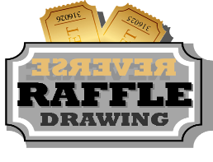
NEZ Past President’s Reverse Raffle
For Incoming State President Stacey Mack
Tickets $20 each ~ GRAND PRIZE $1500
First ticket out and every 25th number gets $25.00
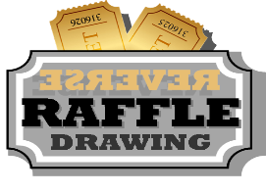
WINNER NEED NOT BE PRESENT
For tickets contact: Joe Taylor 330 509 2617
September 25th, 2022 ~ 1:00 pm
Wellington Eagles #2051 – 631 S. Main St., Wellington Oh 44090
Doors open at 12 noon ~ Lunch at 1:00 pm
RAFFLES TO FOLLOW

